LAB 10

1. Write a function in python to read the content from a text file "ABC.txt" line by line and display the same on screen.

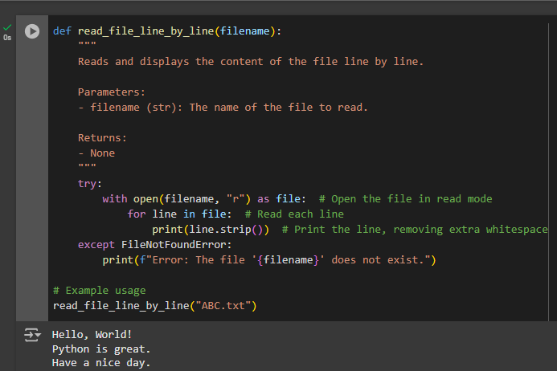

2. Write a function in Python to count and display the total number of words in a text file “ABC.txt”

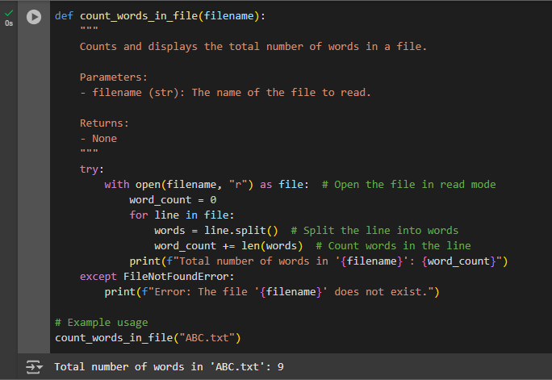

3. Write a function in Python to count uppercase character in a text file “ABC.txt”

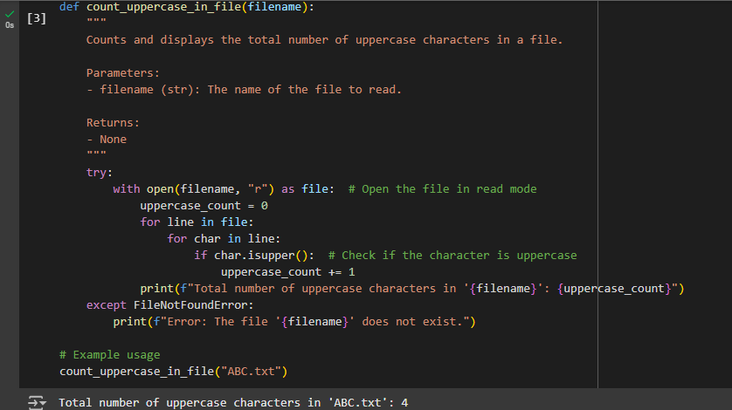

4. Write a function display_words() in python to read lines from a text file "story.txt", and display those words, which are less than 4 characters

